MicroProject Report

Circular Bus/Train Ticket Queue Management System Using Circular Queue
Soham Rane D7B 39

1. Problem and Objectives

Problem Statement
Bus and train stations frequently need to manage passengers waiting to board. Passengers must be served in the order in which they join the waiting line. Once a passenger boards, the space occupied by that passenger should become available for another passenger.
A simple linear array queue can waste available array positions after dequeue operations if its implementation does not reuse freed positions. Repeatedly shifting passengers to the beginning of the array is another possible solution, but it introduces unnecessary operations.
This project addresses the problem by implementing a Circular Queue using a fixed-size array in Java. The circular queue maintains the correct First In, First Out (FIFO) order while allowing freed array positions to be reused through circular indexing.
The application simulates passenger boarding using sample passenger records and provides a menu through which the user can manage and inspect the waiting queue.

Objectives
The main objectives are:
- To understand and implement the circular queue data structure using an array without relying on Java's built-in queue implementations.
- To maintain FIFO order during passenger boarding.
- To implement enqueue, dequeue, peek, search, and traversal operations.
- To demonstrate circular indexing and reuse of freed array positions.
- To handle queue overflow, queue underflow, and invalid user input.
- To display the internal queue state, including front and rear indices, capacity, and current size.
- To maintain a record of passengers who have boarded. // we used ArrayList
- To analyze the time and space complexity of the implemented operations.

Intended Users-students, instructors, and anyone interested in understanding how a circular queue can be applied

1.4 Functional Requirements
The application must support the following operations:
Requirement ID | Functional requirement
FR1 | Add a passenger to the rear of the waiting queue.
FR2 | Board and remove the passenger at the front of the queue.
FR3 | Display the next passenger without removing them.
FR4 | Display all waiting passengers in FIFO order.
FR5 | Search for a waiting passenger using a ticket number.
FR6 | Display the physical array, front and rear indices, size, capacity, and queue status.
FR7 | Display the boarding history.
FR8 | Reject insertion when the queue is full and handle removal attempts when it is empty.
FR9 | Validate menu input and reject empty passenger names or destinations.
FR10 | Terminate the application when the user selects the exit option.

Scope
The project includes:
- A fixed-capacity circular queue.
- Passenger records containing ticket number, name, and destination.
- FIFO-based boarding.
- Circular array traversal.
- Passenger search within the waiting queue.
- Boarding history.
- Console-based interaction and input validation.
The project does not include real-time train or bus schedules, ticket payment, authentication, a database, a graphical interface, or integration with an actual transport service.

1.6 Assumptions
- Each passenger receives a unique ticket number during a program execution.
- The queue has a fixed capacity of five passengers in the demonstration.
- Passengers are boarded in FIFO order.
- Only passengers currently waiting are included in the waiting-queue search.
- Passenger records are sample data created for educational purposes.
- The queue and boarding history remain in memory only for the duration of the program.
- A successful dequeue represents a passenger boarding the bus or train.
- The implementation is single-user and single-threaded.

2. Data Structure Selection and Analysis

Selected Data Structure: Circular Queue
A circular queue is a linear data structure that follows the First In, First Out principle. It uses a fixed-size array in which the logical end connects back to the beginning.
Unlike a simple linear array queue, a circular queue can reuse positions freed by dequeue operations without shifting the remaining elements.
In this project, the circular queue is implemented manually in Java using a Passenger[] array.

Why a Circular Queue Is Suitable
The transport boarding scenario naturally follows FIFO ordering. A passenger who joins first should board before passengers who join later.
A circular queue is appropriate because:
- Enqueue inserts passengers at the rear.
- Dequeue removes passengers from the front.
- The front and rear indices wrap around using modulo arithmetic.
- Empty array positions can be reused after passengers board.
- Enqueue and dequeue take constant time under normal operation.
- The fixed capacity provides a clear upper limit for the number of waiting passengers.
The circular queue is therefore well suited to demonstrating efficient, ordered boarding in a bounded waiting area.

Comparison with an Alternative: Linear Array Queue
A linear array queue is a reasonable alternative because it also follows FIFO order and can be implemented without built-in queue classes.
However, a simple implementation using front and rear indices may leave unused positions at the beginning of the array after dequeue operations.
Feature | Linear array queue | Circular array queue
FIFO ordering | Supported | Supported
Array storage | Fixed-size array | Fixed-size array
Reuses freed positions at the beginning | Not automatically in a simple implementation | Yes
Element shifting required | May be needed to reclaim space | Not required
Enqueue | Usually O(1), until rear reaches the end | O(1)
Dequeue | O(1) if the front index advances | O(1)
Index wraparound | No | Yes
Implementation complexity | Simpler | Requires circular indexing and careful state management
The circular queue is selected because it addresses the unused-space problem while preserving FIFO order and avoiding repeated shifting.

Stored Fields and Variables

Passenger record
Each passenger is represented by a Passenger object.
Field | Data type | Description
ticketNumber | int | Unique ticket identifier
name | String | Passenger's name
destination | String | Passenger's destination
The fields are declared private final so that they cannot be directly modified or reassigned after the passenger object is constructed.

Circular queue state
Variable | Data type | Purpose
queue | Passenger[] | Stores passenger references
capacity | int | Maximum number of waiting passengers
front | int | Index of the next passenger to board
rear | int | Index of the last passenger in the queue
size | int | Current number of waiting passengers
The demonstration uses a capacity of five.

Boarding history
The original implementation maintains a separate boarding-history collection containing successfully boarded passengers. This collection is not used to implement the waiting queue.
For the strictest interpretation of the instructor's restriction on built-in data structures, the final submission should use a manually managed array for boarding history as well.

Handling Duplicates
The application generates sequential ticket numbers beginning at 104 for newly added passengers, following the three sample passengers with ticket numbers 101, 102, and 103. This helps ensure unique ticket numbers during normal program execution.
Names and destinations are not required to be unique. Two passengers may have the same name or destination while retaining different ticket numbers.

Empty and Full Queue Conditions
The implementation uses a size counter to distinguish empty and full states.
- Empty queue: size == 0
- Full queue: size == capacity
This distinction is necessary because front == rear alone cannot distinguish an empty queue from a queue containing exactly one passenger, and in this implementation equal pointer indices may also occur when the queue is full.
The size counter provides an unambiguous distinction without reserving an array position.

3. Design and Algorithms

System Design
The program consists of three principal components.

A. Passenger-Represents one passenger and stores the ticket number, name, and destination.

B. CircularPassengerQueue-Implements the circular queue using an array. It manages insertion, removal, traversal, searching, status inspection, and boarding history.

C. TransportQueueSystem-Contains the main() method, displays the menu, reads input, validates user choices, and invokes the relevant queue methods.
The main class does not implement the queue operations itself. It delegates them to CircularPassengerQueue.

Queue Initialization
The queue constructor initializes the state as follows:
capacity = supplied capacity
front = 0
rear = -1
size = 0
The array is created with the specified capacity.
The initial value rear = -1 indicates that no passenger has yet been inserted. The first successful enqueue moves the rear to index zero.
A non-positive capacity is rejected using an IllegalArgumentException.

Enqueue Algorithm
Purpose: Insert a passenger at the rear of the queue.
Pseudocode:
ENQUEUE(passenger)

IF size == capacity
DISPLAY "Queue is full"
RETURN failure
END IF

rear = (rear + 1) MOD capacity
queue[rear] = passenger
size = size + 1

DISPLAY insertion success
RETURN success

END ENQUEUE
The modulo operation ensures that the rear index returns to zero after reaching the final array position.

Dequeue Algorithm
Purpose: Remove and return the passenger at the front.
DEQUEUE()

IF size == 0
DISPLAY "Queue is empty"
RETURN no passenger
END IF

boarded = queue[front]
queue[front] = NULL

front = (front + 1) MOD capacity
size = size - 1

RECORD boarded passenger in history
RETURN boarded

END DEQUEUE
The passenger is retrieved before the array slot is cleared. The front index is advanced, and the size is reduced by one.

Peek Algorithm
Purpose: View the next passenger without removing them.
PEEK()

IF size == 0
DISPLAY "Queue is empty"
RETURN no passenger
END IF

RETURN queue[front]

END PEEK
Peek does not modify the queue's pointers, contents, or size.

Display Queue Algorithm
Purpose: Display passengers in their logical FIFO order, including when the queue wraps around.
DISPLAY_QUEUE()

IF size == 0
DISPLAY "No passengers are waiting"
RETURN
END IF

FOR i = 0 TO size - 1
index = (front + i) MOD capacity
DISPLAY queue[index]
END FOR

END DISPLAY_QUEUE
The calculated index is used instead of assuming that the front index is always smaller than the rear index.

Search Algorithm
Purpose: Find a waiting passenger using their ticket number.
SEARCH(ticketNumber)

FOR i = 0 TO size - 1
index = (front + i) MOD capacity

IF queue[index].ticketNumber == ticketNumber
DISPLAY passenger details
RETURN found
END IF
END FOR

DISPLAY "Passenger not found"
RETURN not found

END SEARCH
The search examines only the current waiting queue. It does not search passengers who have already boarded.

Queue Status Algorithm
DISPLAY_STATUS()

DISPLAY capacity
DISPLAY size
DISPLAY front
DISPLAY rear
DISPLAY whether queue is empty
DISPLAY whether queue is full

FOR index = 0 TO capacity - 1
IF queue[index] is NULL
DISPLAY empty slot
ELSE
DISPLAY passenger stored at index
END IF
END FOR

END DISPLAY_STATUS
This operation displays the physical array, making the internal behavior of the circular queue observable.

Circular Indexing Formula
For a circular queue of capacity (C), the next index is:
Nextindex = (currentindex + 1) % capacity ;
For example, if the capacity is five and the rear index is four:
(4+1)mod 5=0
The next insertion therefore uses array index zero, provided the queue is not full.
The display and search methods use:
index=(front+i)mod C
where (i) ranges from zero to size - 1.
This ensures that logical traversal follows the correct FIFO order even when the physical array wraps around.

4. Implementation

Programming Language and Environment
The project is implemented in Java as a console-based application.
The principal data structure is a manually implemented circular queue using an array of Passenger references. Java's built-in queue implementations are not used for the assessed queue operations.
The source file is named TransportQueueSystem.java, and the program can be compiled and executed using:
javac TransportQueueSystem.java
java TransportQueueSystem

Important Methods
Method | Responsibility
Passenger(...) | Initializes passenger data
getTicketNumber() | Returns the ticket number
getName() | Returns the passenger name
getDestination() | Returns the destination
toString() | Formats passenger information
CircularPassengerQueue(...) | Initializes the array and queue state
isEmpty() | Checks whether the queue is empty
isFull() | Checks whether the queue is full
enqueue() | Inserts a passenger
dequeue() | Removes and records the front passenger
peek() | Views the next passenger
displayQueue() | Traverses the logical queue
searchPassenger() | Searches the waiting queue
displayStatus() | Displays internal queue state
displayBoardingHistory() | Displays completed boarding records
readInt() | Validates integer input
readText() | Rejects empty text input
showMenu() | Displays application options
main() | Controls program execution

Important Code Extracts

Array declaration
private final Passenger[] queue;
This declares the array used to store passengers. It is the core storage structure of the implementation.

Enqueue operation
rear = (rear + 1) % capacity;
queue[rear] = passenger;
size++;
These statements calculate the next circular position, store the passenger, and update the queue size.

Dequeue operation
Passenger boarded = queue[front];
queue[front] = null;
front = (front + 1) % capacity;
size--;
These statements retrieve the first passenger, clear the slot, advance the front pointer, and update the size.

Circular traversal
for (int i = 0; i < size; i++) {
int index = (front + i) % capacity;
System.out.println(queue[index]);
}
This traversal handles wraparound without shifting the contents of the array.

Input Validation and Error Handling
The program includes the following safeguards:
- The constructor rejects non-positive queue capacities.
- enqueue() rejects insertion when the queue is full.
- dequeue() handles attempts to board when the queue is empty.
- peek() handles attempts to inspect an empty queue.
- readInt() catches NumberFormatException when the user enters invalid integer input.
- readText() rejects blank passenger names and destinations.
- The menu's default case handles invalid menu choices.
The application uses a Scanner for console input. This is an input utility and does not replace the assessed queue data structure.

Program Execution Flow
- The program creates a circular queue with capacity five.
- Three sample passengers are inserted.
- The menu is displayed.
- The user selects an operation.
- The main class validates and processes the input.
- The relevant circular queue method is invoked.
- The updated result is displayed.
- The menu repeats until the user chooses to exit.

5. Dry Run and Complexity Analysis

Initial State
The queue capacity is five, and the program inserts the following sample passengers:
Ticket number | Name | Destination
101 | Aarav | Thane
102 | Meera | Dadar
103 | Rohan | Panvel
The initial state after these insertions is:
Array: [101, 102, 103, EMPTY, EMPTY]
Front = 0
Rear = 2
Size = 3
Capacity = 5

Dry Run Through Seven Meaningful Operations
The following sequence demonstrates normal insertion, reaching full capacity, dequeue operations, circular wraparound, and reuse of freed positions.
Step | Operation | Front | Rear | Size | Logical queue order
0 | Initial state | 0 | 2 | 3 | 101, 102, 103
1 | Enqueue 104 | 0 | 3 | 4 | 101, 102, 103, 104
2 | Enqueue 105 | 0 | 4 | 5 | 101, 102, 103, 104, 105
3 | Dequeue 101 | 1 | 4 | 4 | 102, 103, 104, 105
4 | Dequeue 102 | 2 | 4 | 3 | 103, 104, 105
5 | Enqueue 106 | 2 | 0 | 4 | 103, 104, 105, 106
6 | Enqueue 107 | 2 | 1 | 5 | 103, 104, 105, 106, 107
At Step 5, the rear wraps from index four to index zero. At Step 6, it advances from index zero to index one.
The final physical array is:
Index: 0 1 2 3 4
Array: 106 107 103 104 105
The final state is:
Front = 2
Rear = 1
Size = 5
Capacity = 5
Although the physical array begins with tickets 106 and 107, the logical queue begins at front = 2. The correct boarding order is therefore 103, 104, 105, 106, and 107.
This confirms that circular traversal maintains FIFO ordering across the array boundary.
Complexity Analysis
Let (n) represent the current number of waiting passengers, (C) represent the fixed queue capacity, and (b) represent the number of recorded boarding events.
Operation | Time complexity | Explanation
Enqueue | O(1) | Updates one index and one array slot
Dequeue | O(1) | Removes one passenger and advances the front
Peek | O(1) | Accesses the front position directly
Is empty | O(1) | Checks the size counter
Is full | O(1) | Compares size with capacity
Search | O(n) worst case | May inspect every waiting passenger
Display queue | O(n) | Prints all waiting passengers
Display status | O(C) | Inspects every array slot
Display history | O(b) | Prints all recorded boardings
The circular queue requires O(C) space for its array. The boarding history requires additional space proportional to the number of recorded boardings.
The principal advantage is that enqueue and dequeue do not require shifting the remaining passengers.

6. Testing and Results

Testing Approach
The application should be tested for normal operation, boundary conditions, circular wraparound, and invalid input.
The following test cases define the expected behavior. The actual-result and status fields must be completed after executing the program and observing its output. They must not be marked as passed without verification.

Test Cases
Test ID | Input or action | Expected result
TC01 | Start the program | Three sample passengers are inserted; front = 0, rear = 2, size = 3
TC02 | Select option 1 and enter Nisha and Borivali | Passenger 104 is inserted; rear = 3, size = 4
TC03 | Select option 3 | The passenger at the front is displayed without changing the queue
TC04 | Fill all five positions and attempt another insertion | The queue-full message is displayed; no insertion occurs
TC05 | Board the front passenger | The earliest waiting passenger is removed; front advances and size decreases
TC06 | Attempt to board when the queue is empty | The empty-queue message is displayed; no passenger is removed
TC07 | Fill the queue, dequeue two passengers, then enqueue two more | The rear wraps around and the freed array positions are reused
TC08 | Search for ticket 103 while that passenger is waiting | Passenger details and the correct array index are displayed
TC09 | Search for a nonexistent ticket number | The passenger-not-found message is displayed
TC10 | Enter alphabetic text at the menu-choice prompt | The input error is handled and the program requests another integer
TC11 | Enter an empty passenger name | The program rejects the blank value and asks again
TC12 | Select option 8 | The program exits the menu loop and closes the scanner

Testing Results
The table above is the planned test matrix. The implementation's actual results have not yet been recorded in this report.
After execution, replace each pending entry with the observed behavior and mark the test as Pass or Fail. If a test fails, record the discrepancy and correct the implementation before submission.
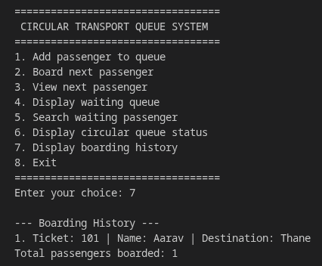
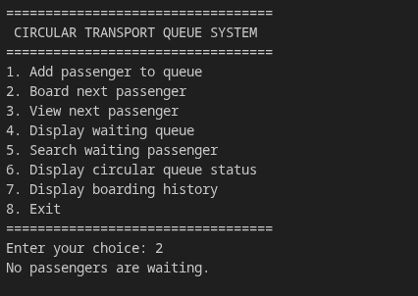
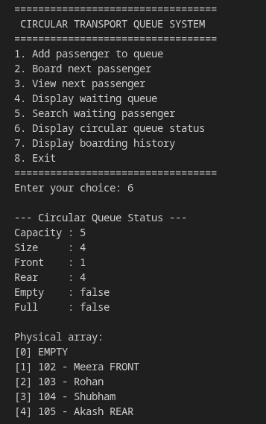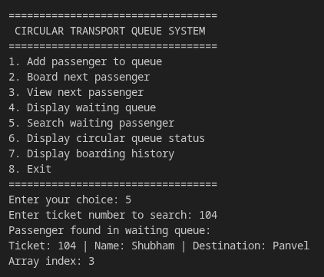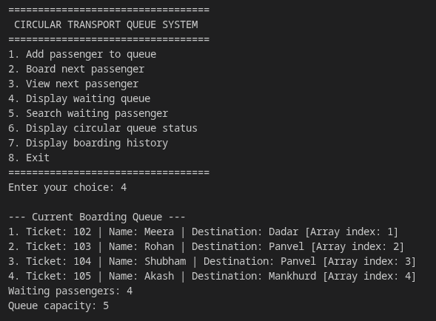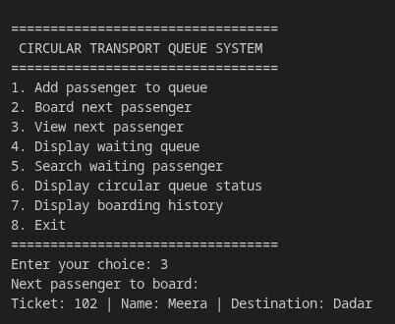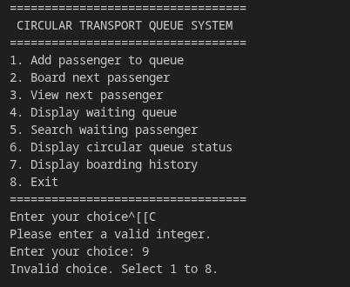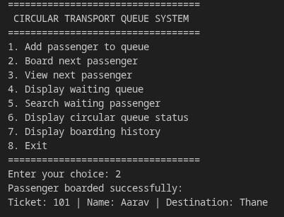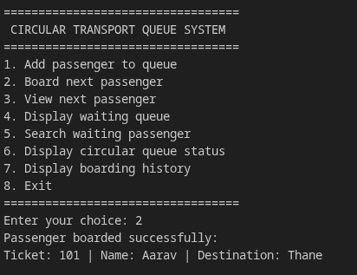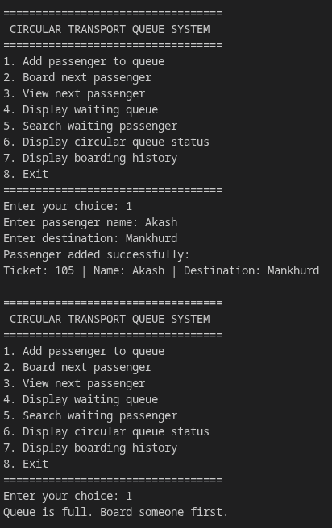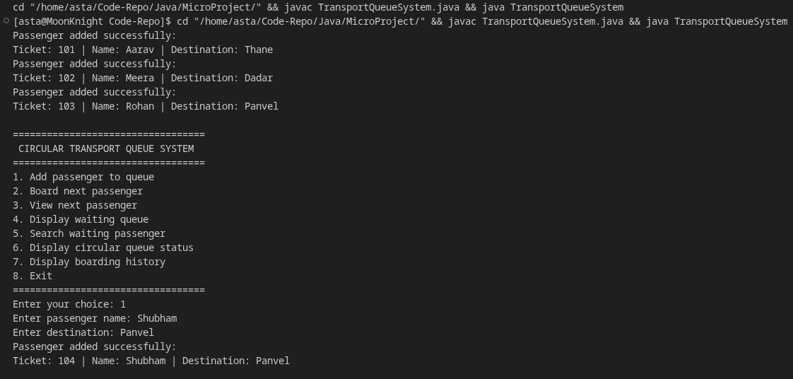

7. Conclusion and References

Conclusion
The Circular Bus/Train Queue Management System demonstrates how a circular queue can be applied to passenger boarding.
The project implements the principal data structure manually using a fixed-size array, together with front, rear, and size variables. Enqueue, dequeue, peek, traversal, and search operations demonstrate how the queue maintains FIFO ordering.
Modulo arithmetic enables the indices to wrap around to the beginning of the array. As a result, positions freed by boarded passengers can be reused without shifting the remaining elements.
The implementation also includes overflow and underflow handling, input validation, queue-state inspection, and boarding history. The project therefore provides a practical demonstration of the relationship between a data structure, its algorithms, and a real-world use case.
The implementation is designed for educational demonstration and does not represent a complete operational transport system.

Limitations
- The queue has a fixed capacity and cannot grow dynamically.
- The application uses sample records rather than live passenger data.
- The program does not persist records between executions.
- The search operation examines the waiting queue linearly.
- The application does not integrate with transport schedules, ticketing, or payment systems.
- Boarding history grows as additional passengers board and would require a storage policy for a long-running system.

Future Improvements
Possible improvements include:
- A graphical user interface.
- Persistent storage for passenger records and boarding history.
- Validation of station names and destinations.
- Cancellation of waiting passengers.
- Separate queues for multiple buses or trains.
- Passenger-priority handling where required by a defined boarding policy.
- Automated unit tests for edge cases and circular indexing.
- A manually managed array for boarding history to avoid unnecessary reliance on collection classes.

Learning Outcomes
Through this project, we aim to demonstrate an understanding of:
- FIFO behavior and queue operations.
- Array-based implementation of a circular queue.
- Front and rear pointer management.
- Modulo arithmetic for wraparound.
- Queue overflow and underflow.
- Reuse of freed array positions.
- Invariants and boundary conditions.
- Algorithmic time and space complexity.
- The importance of testing a data structure under normal and exceptional conditions.

References
- Oracle. Java Platform, Standard Edition Documentation. Available at: https://docs.oracle.com/en/java/
- Oracle. Java Language and API Documentation. Available at: https://docs.oracle.com/en/java/javase/
- Horowitz, E., Sahni, S., and Anderson-Freed, S. Fundamentals of Data Structures in C. W. H. Freeman. Refer to the relevant queue and array-based data structure concepts.
- Course notes and lecture materials on queues, circular queues, array representation, and algorithm complexity provided by the Data Structures instructor.

End

import java.util.ArrayList;
import java.util.Scanner;
class Passenger {
private final int ticketNumber;
private final String name;
private final String destination;
public Passenger(int ticketNumber, String name, String destination) {
this.ticketNumber = ticketNumber;
this.name = name;
this.destination = destination;
}
public int getTicketNumber() {
return ticketNumber;
}
public String getName() {
return name;
}
public String getDestination() {
return destination;
}
@Override
public String toString() {
return "Ticket: " + ticketNumber
+ " | Name: " + name
+ " | Destination: " + destination;
}}
class CircularPassengerQueue {
private final Passenger[] queue;
private final int capacity;
private int front;
private int rear;
private int size;
private final ArrayList<Passenger> boardingHistory;
public CircularPassengerQueue(int capacity) {
if (capacity <= 0) {
throw new IllegalArgumentException(
"Capacity must be greater than zero.");}
this.capacity = capacity;
this.queue = new Passenger[capacity];
front = 0;
rear = -1;
size = 0;
boardingHistory = new ArrayList<>();}
public boolean isEmpty() {
return size == 0;}
public boolean isFull() {
return size == capacity;}
public int getSize() {
return size;}
public int getCapacity() {
return capacity;}
public int getFrontIndex() {
return front;}
public int getRearIndex() {
return rear;}
public boolean enqueue(Passenger passenger) {
if (isFull()) {
System.out.println(
"Queue is full! No more passengers can join."
);
return false;
}
rear = (rear + 1) % capacity;
queue[rear] = passenger;
size++;
System.out.println("Passenger added successfully:");
System.out.println(passenger);
return true;}
public Passenger dequeue() {
if (isEmpty()) {
System.out.println("No passengers are waiting.");
return null;}
Passenger boarded = queue[front];
queue[front] = null;
front = (front + 1) % capacity;
size--;
boardingHistory.add(boarded);
System.out.println("Passenger boarded successfully:");
System.out.println(boarded);
return boarded;}
public Passenger peek() {
if (isEmpty()) {
System.out.println("The queue is empty.");
return null;}
return queue[front];}
public void displayQueue() {
if (isEmpty()) {
System.out.println("No passengers are waiting.");
return;}
System.out.println("\n--- Current Boarding Queue ---");
for (int i = 0; i < size; i++) {
int index = (front + i) % capacity;
System.out.println(
(i + 1) + ". " + queue[index]
+ " [Array index: " + index + "]");}
System.out.println("Waiting passengers: " + size);
System.out.println("Queue capacity: " + capacity);}
public void searchPassenger(int ticketNumber) {
for (int i = 0; i < size; i++) {
int index = (front + i) % capacity;
Passenger passenger = queue[index];
if (passenger.getTicketNumber() == ticketNumber) {
System.out.println("Passenger found in waiting queue:");
System.out.println(passenger);
System.out.println("Array index: " + index);
return;}}
System.out.println(
"No waiting passenger found with ticket number "
+ ticketNumber + ".");}
public void displayStatus() {
System.out.println("\n--- Circular Queue Status ---");
System.out.println("Capacity : " + capacity);
System.out.println("Size : " + size);
System.out.println("Front : " + front);
System.out.println("Rear : " + rear);
System.out.println("Empty : " + isEmpty());
System.out.println("Full : " + isFull());
System.out.println("\nPhysical array:");
for (int i = 0; i < capacity; i++) {
String label = "";
if (size > 0 && i == front) {
label += " FRONT";}
if (size > 0 && i == rear) {
label += " REAR";}
if (queue[i] == null) {
System.out.println(
"[" + i + "] EMPTY" + label
);
} else {
System.out.println(
"[" + i + "] "
+ queue[i].getTicketNumber()
+ " - " + queue[i].getName()
+ label);}}}
public void displayBoardingHistory() {
System.out.println("\n--- Boarding History ---");
if (boardingHistory.isEmpty()) {
System.out.println("No passengers have boarded yet.");
return;}
for (int i = 0; i < boardingHistory.size(); i++) {
System.out.println(
(i + 1) + ". " + boardingHistory.get(i));}
System.out.println(
"Total passengers boarded: " + boardingHistory.size());}}
public class TransportQueueSystem {
private static final Scanner scanner = new Scanner(System.in);
private static int nextTicketNumber = 104;
private static int readInt(String prompt) {
while (true) {
System.out.print(prompt);
try {
return Integer.parseInt(scanner.nextLine().trim());
} catch (NumberFormatException e) {
System.out.println("Please enter a valid integer.");}}}
private static String readText(String prompt) {
while (true) {
System.out.print(prompt);
String value = scanner.nextLine().trim();
if (!value.isEmpty()) {
return value;}
System.out.println("Input cannot be empty.");}}
private static void showMenu() {
System.out.println("\n==================================");
System.out.println(" CIRCULAR TRANSPORT QUEUE SYSTEM");
System.out.println("==================================");
System.out.println("1. Add passenger to queue");
System.out.println("2. Board next passenger");
System.out.println("3. View next passenger");
System.out.println("4. Display waiting queue");
System.out.println("5. Search waiting passenger");
System.out.println("6. Display circular queue status");
System.out.println("7. Display boarding history");
System.out.println("8. Exit");
System.out.println("==================================");}
public static void main(String[] args) {
CircularPassengerQueue queue =
new CircularPassengerQueue(5);
queue.enqueue(new Passenger(101, "Aarav", "Thane"));
queue.enqueue(new Passenger(102, "Meera", "Dadar"));
queue.enqueue(new Passenger(103, "Rohan", "Panvel"));
boolean running = true;
while (running) {
showMenu();
int choice = readInt("Enter your choice: ");
switch (choice) {
case 1: {
if (queue.isFull()) {
System.out.println(
"Queue is full. Board someone first.");
break;}
String name = readText("Enter passenger name: ");
String destination =
readText("Enter destination: ");

Passenger passenger = new Passenger(
nextTicketNumber, name, destination);
if (queue.enqueue(passenger)) {
nextTicketNumber++;}
break;}
case 2:
queue.dequeue();
break;
case 3: {
Passenger passenger = queue.peek();
if (passenger != null) {
System.out.println(
"Next passenger to board:");
System.out.println(passenger);}
break;}
case 4:
queue.displayQueue();
break;
case 5: {
int ticket = readInt(
"Enter ticket number to search: ");
queue.searchPassenger(ticket);
break;}
case 6:
queue.displayStatus();
break;

case 7:
queue.displayBoardingHistory();
break;
case 8:
running = false;
System.out.println(
"Transport Queue System closed.");
break;
default:
System.out.println(
"Invalid choice. Select 1 to 8.");}}
scanner.close();}}

